Name : Kirtesh Satish Admute
Roll No. : 258039
PRN : 250841220082
Module : DBT

CREATE TABLE Worker (
first_name VARCHAR(50),
last_name VARCHAR(50),
department VARCHAR(50),
salary DECIMAL(10, 2),
join_date DATE,
role VARCHAR(50),
manager_flag TINYINT(1)
);
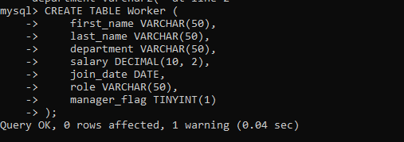

INSERT INTO Worker (first_name, last_name, department, salary, join_date, role, manager_flag) VALUES
('Amitabh', 'Bachchan', 'Admin', 120000.00, '2014-02-15', 'Manager', 1),
('Vipul', 'Sharma', 'IT', 90000.00, '2015-06-01', 'Developer', 0),
('Satish', 'Kumar', 'HR', 60000.00, '2014-02-20', 'Recruiter', 0),
('Anita', 'Singh', 'Admin', 75000.00, '2013-11-05', 'Assistant', 0),
('Rajesh', 'Gupta', 'IT', 110000.00, '2014-02-10', 'Manager', 1),
('Kavita', 'Verma', 'Marketing', 50000.00, '2016-03-25', 'Executive', 0),
('Ramesh', 'Patel', 'Finance', 48000.00, '2017-01-30', 'Analyst', 0),
('Satya', 'Nayak', 'Admin', 100000.00, '2014-02-05', 'Manager', 1),
('Neha', 'Jain', 'IT', 95000.00, '2018-07-18', 'Developer', 0),
('Suresh', 'Das', 'HR', 52000.00, '2014-02-22', 'Recruiter', 0),
('Anjali', 'Shah', 'Marketing', 45000.00, '2019-12-10', 'Executive', 0),
('Asha', 'Mehta', 'Finance', 70000.00, '2014-02-11', 'Analyst', 0),
('Satwik', 'Roy', 'IT', 120000.00, '2014-02-01', 'Manager', 1);

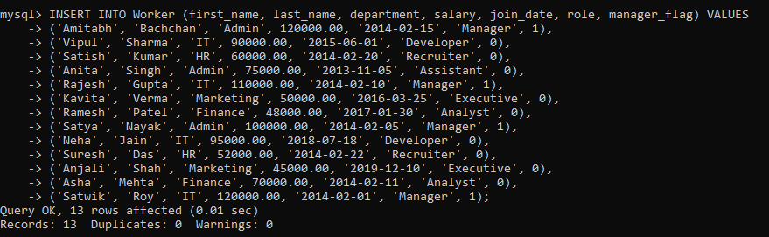

- Write an SQL query to fetch “FIRST_NAME” from Worker table using the alias name as . select first_name "WORKER_NAME" from worker;

select first_name "WORKER_NAME" from worker;

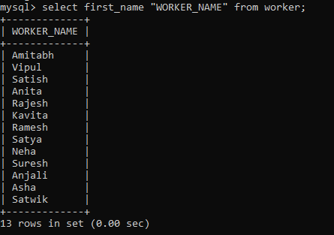

2. Write an SQL query to fetch “FIRST_NAME” from Worker table in upper case.

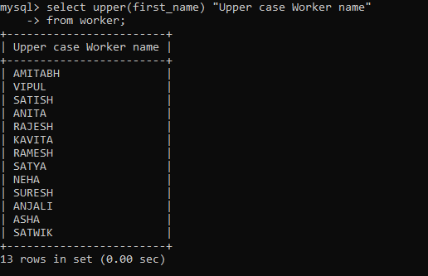
3. Write an SQL query to fetch unique values of DEPARTMENT from Worker table.
select distinct department "Department" from worker;
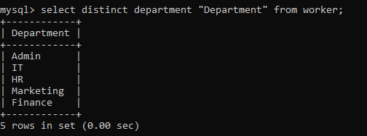
4. Write an SQL query to print the first three characters of FIRST_NAME from Worker table.
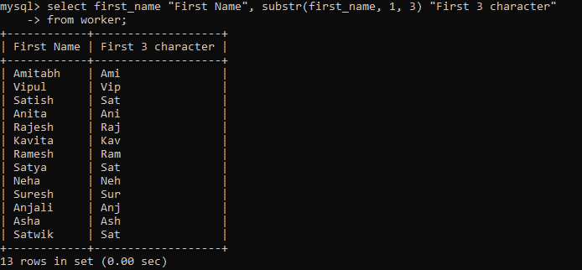
select first_name "First Name", substr(first_name, 1, 3) "First 3 character" from worker;

5. Write an SQL query to find the position of the alphabet (‘a’) in the first name column ‘Amitabh’ from Worker table.
select first_name "First Name", instr(first_name , 'a') "Position of 'a'" from worker where first_name = 'Amitabh';

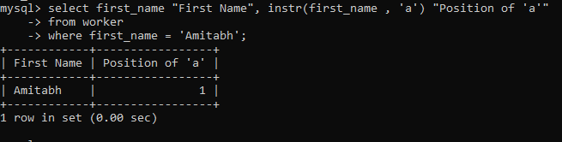

6. Write an SQL query to print the FIRST_NAME , departmentname from Worker table separated by white space.
select first_name "Name", department Department, concat(first_name," , ", department) "Name and Department" from worker;
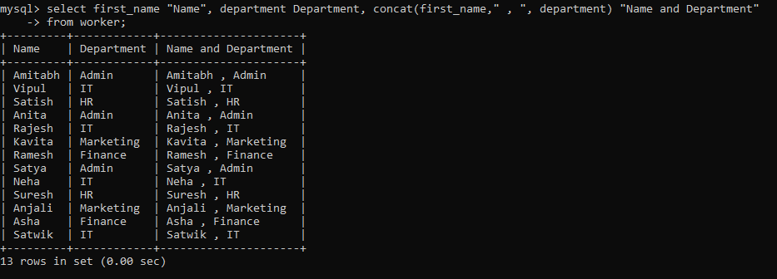

7. Write an SQL query to print the DEPARTMENT from Worker table after removing white spaces from the left side.
select ltrim(department) "Department after Ltrim" from worker;
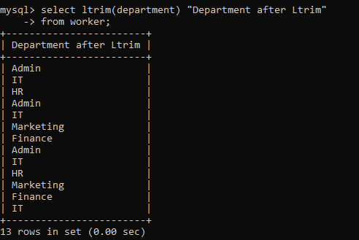

8. Write an SQL query that fetches the unique values of DEPARTMENT from Worker table and prints its length.
select distinct department Department, length(department) Length from worker;
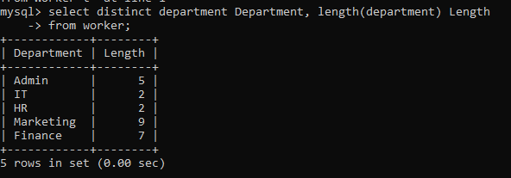

9. Write an SQL query to print the FIRST_NAME from Worker table after replacing ‘a’ with ‘A’.
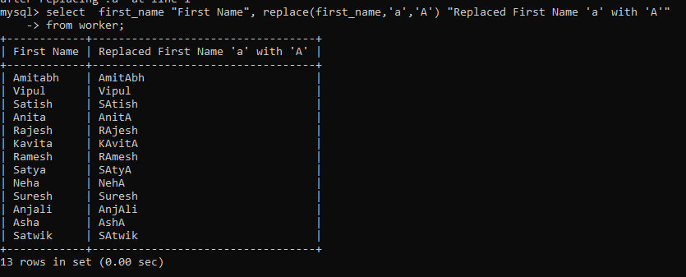
select first_name "First Name", replace(first_name,'a','A') "Replaced First Name 'a' with 'A'" from worker;
10. Write an SQL query to print the FIRST_NAME and LAST_NAME from Worker table into a single column COMPLETE_NAME. A space char should separate them
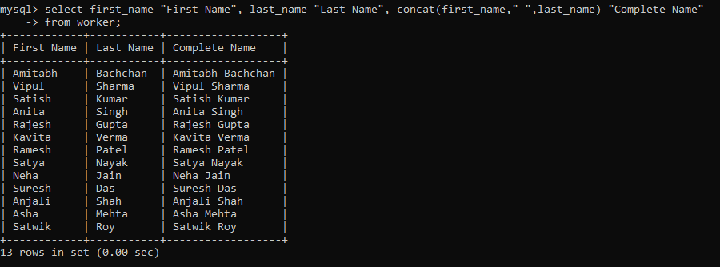
select first_name "First Name", last_name "Last Name", concat(first_name," ",last_name) "Complete Name" from worker;

11. Write an SQL query to print all Worker details from the Worker table order by FIRST_NAME Ascending.
select * from worker order by first_name;
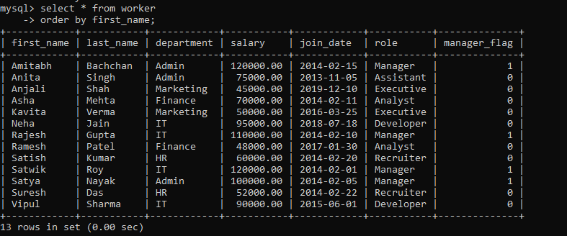
12. Write an SQL query to print all Worker details from the Worker table order by FIRST_NAME Ascending and DEPARTMENT Descending.
select * from worker order by first_name, department desc;
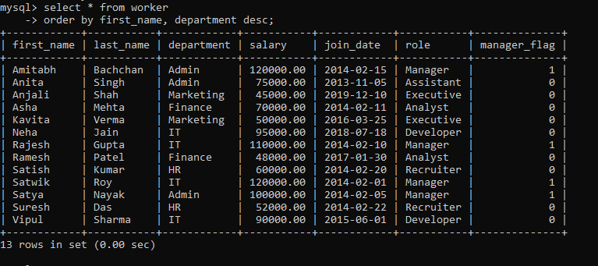
13. Write an SQL query to print details for Workers with the first name as “Vipul” and “Satish” from Worker table
select * from worker where first_name in ('Vipul', 'Satish');
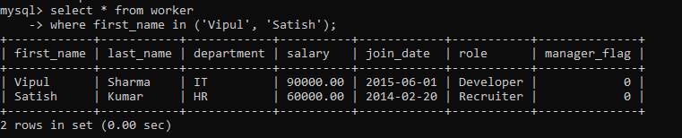

14. Write an SQL query to print details of workers excluding first names, “Vipul” and “Satish” from Worker table.
select * from worker where first_name not in ('Vipul', 'Satish');
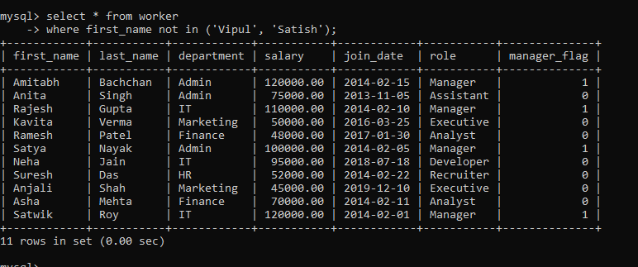
15. Write an SQL query to print details of Workers with DEPARTMENT name as “Admin”.
select * from worker where department = 'Admin';
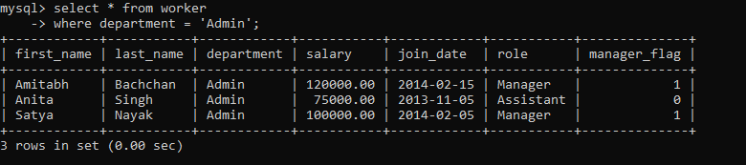
16. Write an SQL query to print details of the Workers whose FIRST_NAME contains ‘a’.
select * from worker where first_name regexp 'a';
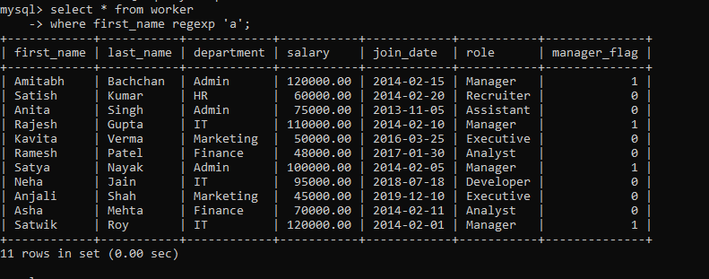

17. Write an SQL query to print details of the Workers whose FIRST_NAME ends with ‘a’
select * from worker where first_name regexp 'a$';
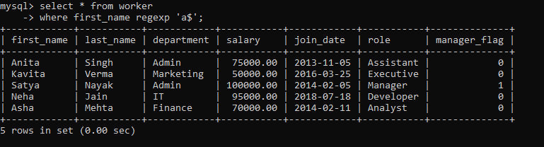
18. Write an SQL query to print details of the Workers whose FIRST_NAME ends with ‘h’ and contains six alphabets.
select * from worker where first_name regexp '^.....h$';
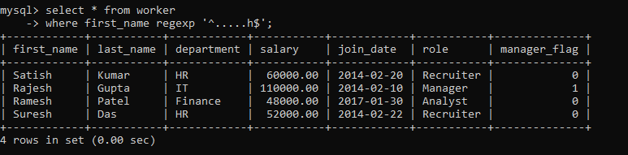

19. Write an SQL query to print details of the Workers whose SALARY lies between 100000 and 500000.
select * from worker where salary between 100000 and 500000;
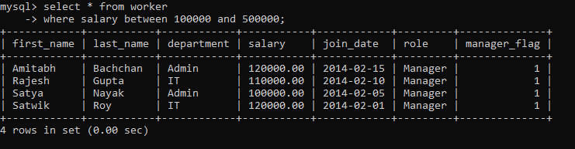
20. Write an SQL query to print details of the Workers who have joined in Feb’2014.
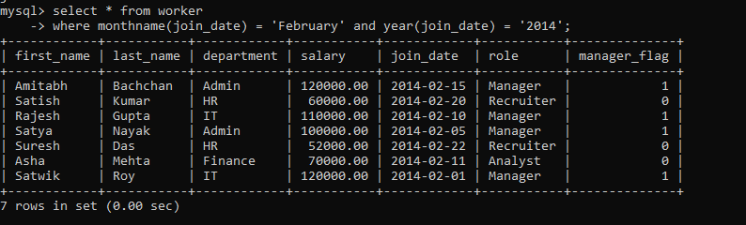
select * from worker where monthname(join_date) = 'February' and year(join_date) = '2014';
21. Write an SQL query to fetch the count of employees working in the department ‘Admin’.
select department, count(*) from worker
where department = 'Admin';
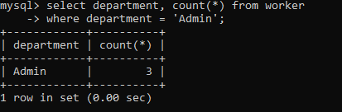
22. Write an SQL query to fetch worker names with salaries >= 50000 and <= 100000.
select first_name from worker where salary between 50000 and 100000;
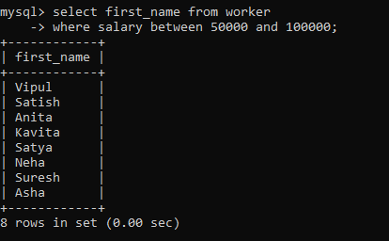
23. Write an SQL query to fetch the no. of workers for each department in the descending order.
select department, count(*) "Number of Worker" from worker group by department order by 2 desc;

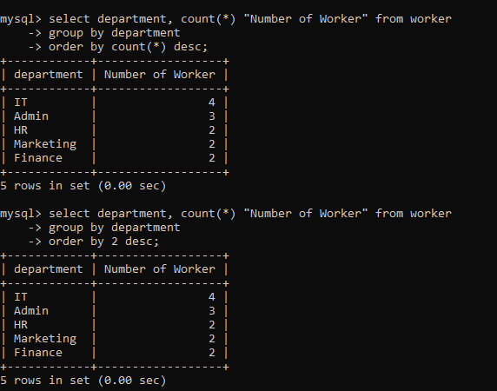

24. Write an SQL query to print details of the Workers who are also Managers
select * from worker where role = 'Manager';
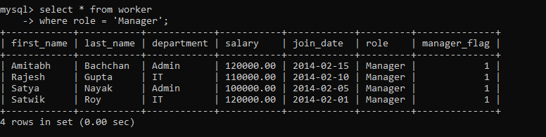
25. Write an SQL query to fetch duplicate records having matching data in some fields of a table.
select count(*) "Duplicate", first_name,department from worker group by first_name, department having count(*) > 1;
26. Write an SQL query to show only odd rows from a table
select * from (select
row_number() over() rn, first_name, last_name, department
from worker) w
where w.rn % 2 != 0;
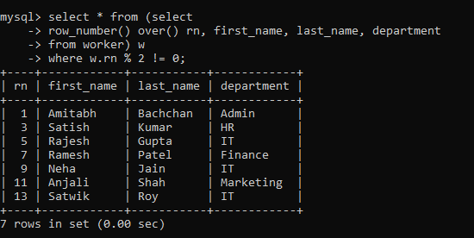

27. Write an SQL query to show only even rows from a table
select * from (select
row_number() over() rn, first_name, last_name, department
from worker) w
where w.rn % 2 = 0;
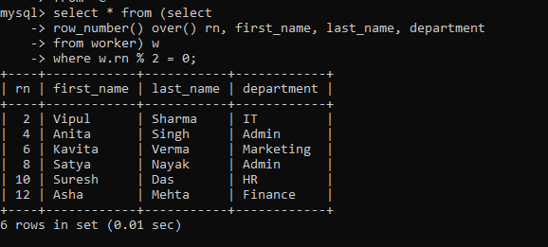

28. Write an SQL query to clone a new table from another table.
create table myWorker AS (select * from worker where 1=2);
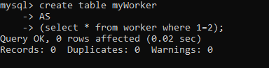
desc myWorker;
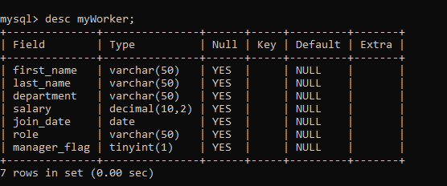
insert into myWorker
select * from worker where salary > 60000;
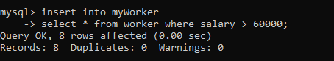

29. Write an SQL query to fetch intersecting records of two tables.
select * from worker
-> intersect
-> select * from myWorker;
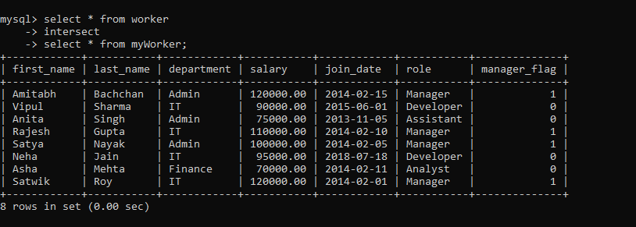
30. Write an SQL query to show records from one table that another table does not have

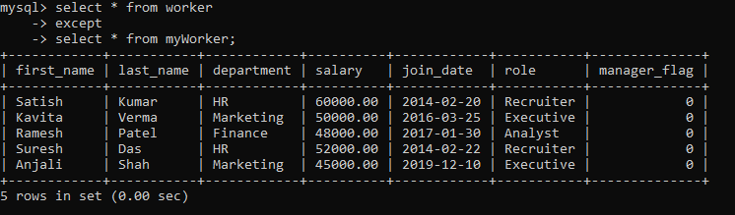
31. Write an SQL query to show the current date and time.
select now() "Current Date and Time";
select sysdate() "Current Date and Time";
select curdate() "Current Date", curtime() "Current Time";
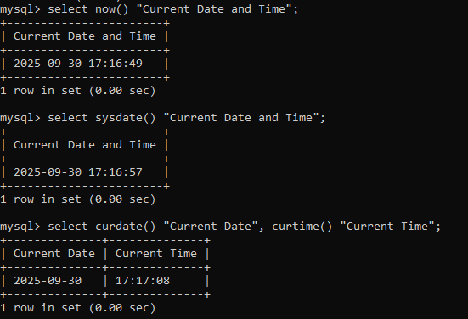

32. Write an SQL query to show the top n (say 10) records of a table.
select * from worker limit 10;
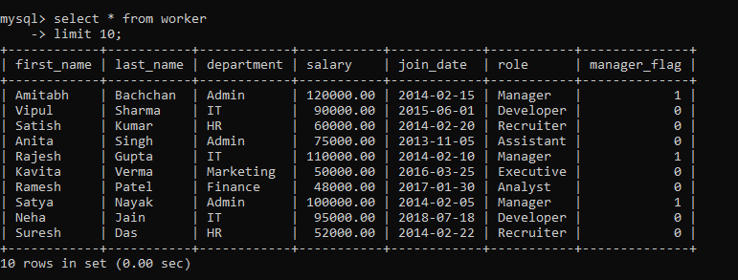
delimiter //
create procedure topRecord(in num int)
begin
select * from worker limit num;
end //
delimiter ;
call topRecord(5);
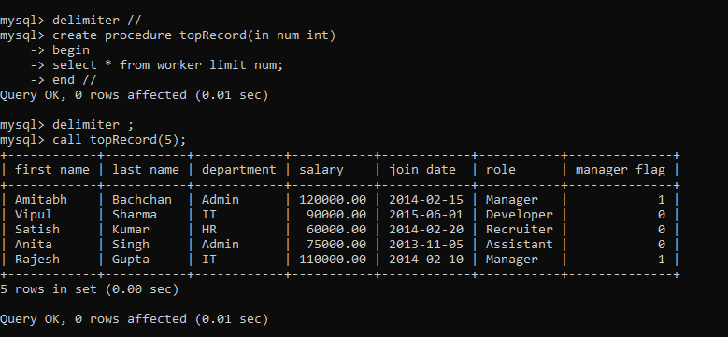

33. Write an SQL query to determine the nth (say n=5) highest salary from a table.
delimiter //
create procedure topSalary(in num int)
begin
select *
from (select first_name, last_name, dense_rank() over(order by salary desc) drk from worker) w
where w.drk <= num;
end //
delimiter ;
call topSalary(5);
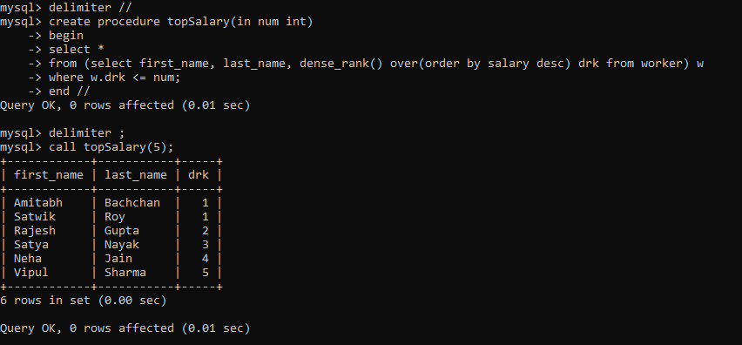
34. Write an SQL query to determine the 5th highest salary without using TOP or limit method.
select *
from (select first_name, last_name, dense_rank() over(order by salary desc) drk from worker) w
where w.drk <= 5;
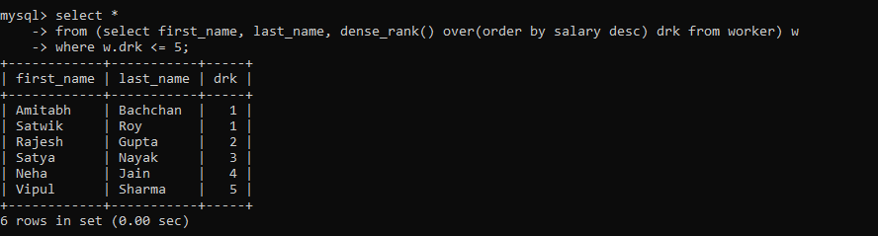

35. Write an SQL query to fetch the list of employees with the same salary
select w.first_name "First worker", w.join_date, w.salary, w1.first_name "Another worker" from worker w, worker w1 where w1.salary = w.salary and w1.join_date < w.join_date;
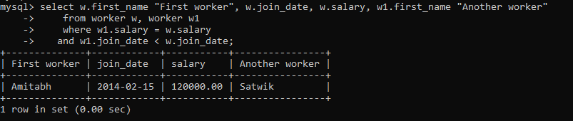

36. Write an SQL query to show the second highest salary from a table.
select * from
-> (select first_name, last_name, salary, dense_rank() over (order by salary desc) drk from worker ) w
-> where w.drk = 2;
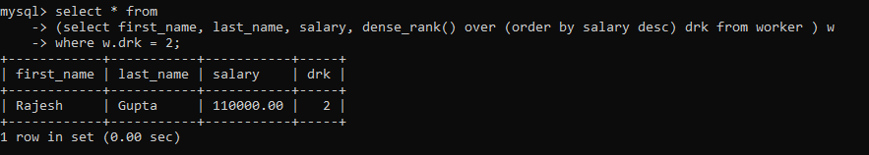
37. Write an SQL query to show one row twice in results from a table.
select *
-> from ( select * from worker
-> union all
-> select * from worker) w
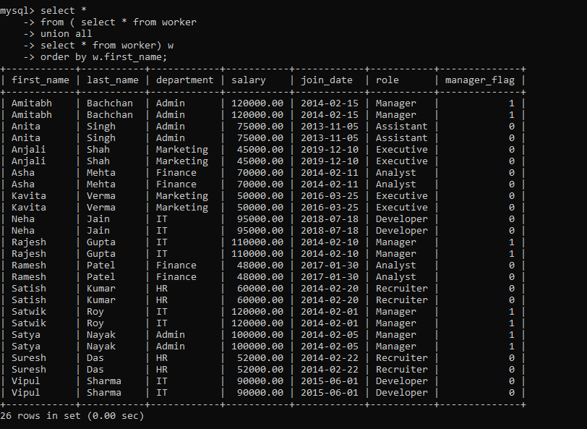
-> order by w.first_name;
38. Write an SQL query to fetch intersecting records of two tables.
select * from worker
-> intersect
-> select * from myWorker;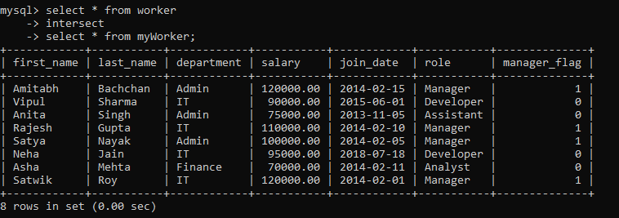
39. Write an SQL query to fetch the first 50% records from a table

40. Write an SQL query to fetch the departments that have less than five people in it
